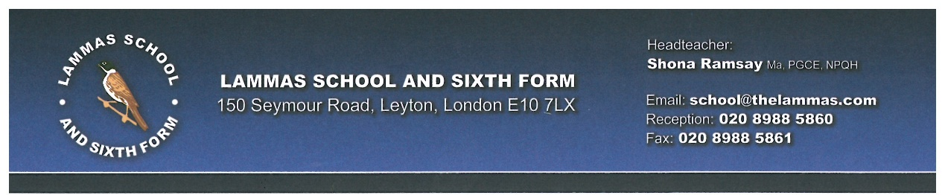

May 2018

Dear Applicant

Re: English Teacher

Thank you very much for your interest in this important and exciting post. I am very pleased to send you information about Lammas School and Sixth Form and the vacancy for an English Teacher. Our school opened in 2001, was designed to a very high standard and was well-funded through the Private Funding Initiative (PFI). We are a truly comprehensive school: a mixed, multicultural fully inclusive 11-18 school serving the local community, with a Sixth Form that opened in 2015.

I am extremely proud to be leading the school on our journey to becoming an outstanding school. We are a confident and caring school and proud of the success gained in our most recent Ofsted Inspection in May 2017, as well as our track record of student outcomes. We are consistently within the top 10% of schools in the country for progress (top 7% in 2016), top 1-2% in English and ranked very highly in our national family of similar schools. (Top school for last 2 years when comparing on basis of prior attainment and disadvantage). We regularly review our progress as a school and have a clear plan for further developments and improvements in the school. Hopefully you will agree with me that this is an exciting time to join the school.

There is a first-rate team of staff at Lammas who have high expectations of and for our students. They are loyal to our students, ambitious for them and never give up. Staff are also committed to their own continuing professional development and we aim to provide a range of opportunities to support their ongoing career progression. After reading the application pack, I hope you will want to join us in addressing the challenges of providing a high quality education for our students. If so, please send your application together with a letter outlining how you feel you are prepared for this post and how you match the person specification.

The closing date for applications is 10am on Monday 21st May 2018.

I look forward to hearing from you.

Yours sincerely,
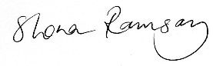

Shona Ramsay
Headteacher

