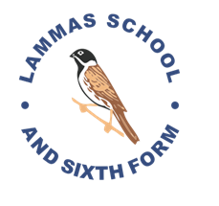

THE ENGLISH DEPARTMENT

The English Department is a key learning area, both for literacy based skills and for the broadening of self-knowledge through writing, and of human sympathies and understanding through literature. The subject offers a major opportunity for developing multicultural and gender awareness, and life skills in general.

Our vision is to foster and cultivate a love for the subject in an environment where everyone has the opportunity to progress, achieve and excel. We never turn a child away. I am extremely proud to say that the majority of our students enjoy the subject. We believe that high achievement and progress stems from a love of the subject. The department has produced outstanding results above national average. The progress of our students can be deemed as outstanding. In the last OFSTED subject inspection we were judged as a good department with areas that are better than good.

Our department is characterised by a strong sense of collaboration and enthusiasm for our subject area and our students. We enjoy an excellent working relationship with staff from other departments. The department consists of a vibrant and dedicated team with varied experience (Assistant Headteacher (Curriculum Leader), Deputy Curriculum Leader, Applied English Co-ordinator, Assistant Headteacher, 2 Student Progress Leaders, two mainscale members of staff (one is also in charge of the Library) and a Learning Support Assistant.

The school has invested heavily in the promotion of literacy across the school, including whole school training, Applied English lessons and in class support. More gifted students have the opportunity to attend English Gifted and Talented Clubs within the department with opportunities to participate in varied outside competitions and initiatives.

As one of the leading departments in the school we aim to attract the very best teaching staff who are committed and dedicated to our students.

