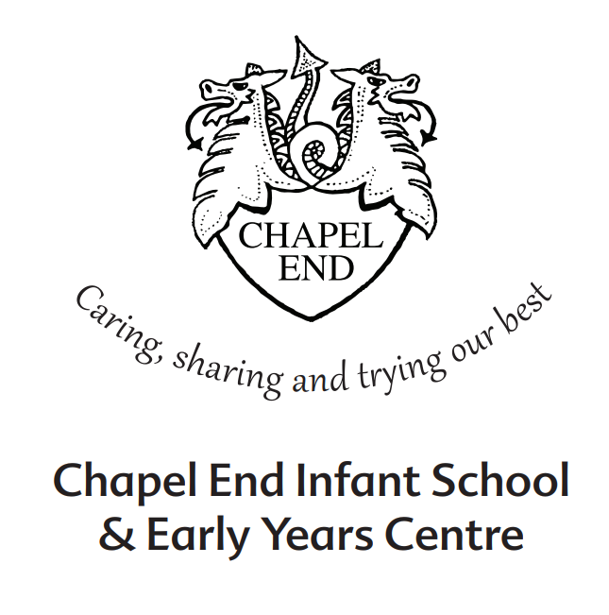

Recruitment Pack
Site Supervisor
Permanent, Full Time Contract
Salary: Scale Point 4 Range 7-10
Hours: 36 hours per week, 10.30am-6.30pm

Waltham Forest Council is committed to safeguarding children, young people, and vulnerable adults.

Dear Applicant,
Thank you for your interest in this exciting opportunity to join Chapel End Infant School and Early Years Centre as a Site Supervisor.
Our vision: ‘To provide the children of Chapel End with a high quality educational experience within a nurturing environment, giving them the best possible start to their lifelong journey’ is what guides us on a daily basis.
We are a welcoming and diverse school set in lovely grounds across two sites. During our recent Ofsted inspection (September 2022), it was noted that ‘warm relationships between staff and pupils are rooted in the school’s values. All are treated with kindness and respect.’
To add to our professional, skilled and friendly team, we wish to appoint a Site Services Officer to care for the school premises and grounds that contribute so much to our schools learning environment. The successful candidate will be willing to contribute towards the effective provision of a clean, safe and well maintained environment for our school community.
It is essential that you are active, trustworthy and conscientious. We are looking for applicants with a high degree of motivation and expect your full commitment.
You will be required to show initiative and promote a positive image of the school through your presence on the school gate and in keeping our grounds and premises maintained to a high standard.
I hope this application pack and the information available generally on our website will give you all the information you need about our school. If you would like to arrange a visit to the school, please contact our school office on: 020 8527 1388 or school@chapelend-inf.waltham.sch.uk.
I look forward to receiving your application pack.

Janice Chaplin
Headteacher

How to Apply
To apply for the post, please complete an application form and include a personal statement, which clearly demonstrates your suitability for this role. Please send your completed application pack via email to school@chapelend-inf.waltham.sch.uk, or drop it off at the Infant school office on Beresford Road (address below).
Closing Date
Please ensure your application arrives by 4.00pm on the closing date of Friday 17th May 2024.
Shortlisting
Shortlisting will take place on Monday 20th May 2024, if you have not heard from us by the end of the day on Tuesday 21st May2024, please assume that unfortunately on this occasion, your application has not been successful.
Interviews
Interviews will take place between Wednesday 22nd and Friday 24th May 2024.
Safeguarding
Applicants called for interview are kindly requested to contact their referees so that references are received ahead of the interview dates.
Chapel End Infant School & Early Years Centre is committed to safeguarding and promoting the welfare of children and young people and expects all staff and volunteers to share this commitment. The school follows safer recruitment practices and the successful applicant will be required to apply for an Enhanced Disclosure and Barring Service check. A copy of our Safeguarding Policy is available to view on our website.
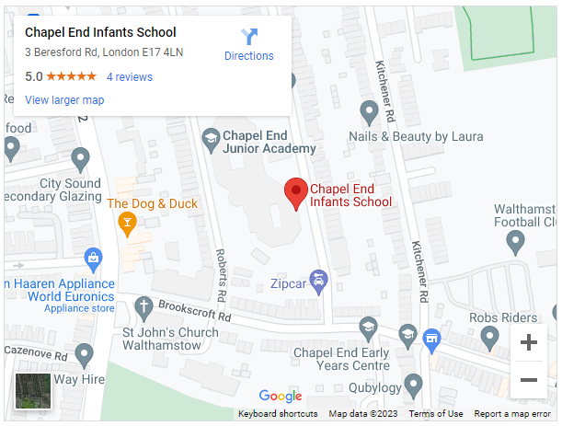
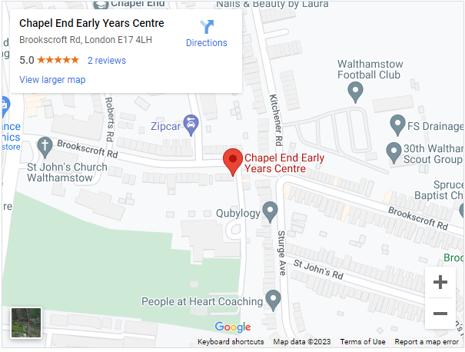
Location



JOB DESCRIPTION

Job Title: Site Supervisor
Department: CYPS
Division: Schools
Grade: Scale 4
Range: 7-10
Responsible to: Head teacher

Job Purpose

Liaising daily with the School Business Manager and Site Services Team on cleaning and caretaking issues, ensuring the security of the school premises. Help maintain the internal and external fabric of the schools premises as a safe working environment.

Key External Contacts
- Contractors and suppliers
- Facilities providers
- Parents
- General Public

Key Internal Contacts
- Head Teacher/School Business Manager/Site Services Officer
- Cleaners
- Staff
- Pupils
Major Tasks, Duties and Responsibilities

1 Key Activities - Operational

Security
- Securely lock/unlock school buildings and areas
- Assist with regular security checks
- Operate alarm systems where appropriate
- Cover lettings

Cleaning and Maintenance
- Assist with minor/simple repairs e.g. minor plumbing, changing light bulbs, unblocking drains, repairing door furniture
- Operation of heating plant, cooling and lighting systems
- Collect and assemble waste for collection
- Undertake sweeping and litter picking
- Undertake emergency cleaning duties
- Undertake routine “client” tasks in connection with premises-related contractors, e.g. cleaning, grounds maintenance
- Provide emergency access to the school site
- Undertake activities to maintain safe and clean external environment e.g. gritting

2 Key Activities - Resources
  - Ensure the maintenance of a clean and orderly working environment
  - Timely & accurate preparation of routine equipment/resources/materials as set out in instructions
  - Undertake basic record keeping as directed
  - Refill and replace consumables e.g. soap & towels
  - Report faulty equipment & other maintenance requirements to appropriate person
  - Maintain the security of school premises by securing entrances/exits as appropriate and reporting potential security breaches
  - Ensure lights and other equipment are switched off as appropriate

3 Key Activities – Organisation & Supervisory
- Escalate any staffing or cleansing/safety concerns to line manager promptly
- Assist with the receipt, distribution, collection and despatch of goods
- Assist and participate in the organisation and movement of furniture within the building
- Maintain and arrange orderly and secure storage of supplies
- Operate everyday equipment in accordance with instructions

4 Responsibilities
- Be aware of and comply with policies and procedures relating to child protection, health, safety and security and confidentiality, reporting all concerns to an appropriate person
- Contribute to the overall ethos/work/aims of the school
- Appreciate and support the role of other professionals
- Attend relevant meetings as required
- Participate in training and other learning activities and performance development as required
- Treat all users of the school with courtesy and consideration
- Present a positive personal image, contributing to a welcoming school environment which supports equal opportunities for all
- Comply with health and safety policies and procedures at all times
- Promote and ensure the health and safety of pupils, staff & visitor (in accordance with appropriate health & safety legislation) at all times.
- The above mentioned duties are neither exclusive nor exhaustive and the post holder may be required to carry out other relevant and/or reasonable duties as directed by their Head Teacher/Line Manager commensurate with the skills, abilities and grade of the post.

Other requirements:
- To have an up-to-date Enhanced DBS Disclosure

Site Supervisor

Person Specification

- Experience

- Handyperson experience

2. Qualifications

    - Willingness to undertake induction training
    - NVQ 1 OR equivalent qualification or equivalent experience or willingness to train to achieve these

3. Knowledge, Skills and Abilities

    - Ability to relate well to children and adults
- Willingness to gain knowledge of health and safety procedures and precautions
- Willingness to gain awareness of COSHH regulations
- Awareness of health and hygiene procedures
- Knowledge of moving and handling procedures
- Ability to work as part of a team
- Willingness to use relevant equipment
- Ability to relate well to children and adults
- Willingness to gain knowledge of cleaning procedures required to meet specified cleaning standards

Equality Statement
Waltham Forest is a diverse borough where diversity is valued and is integral to both service delivery and employment of its staff.
The Council is proud of its rich mix of communities and as the largest employer in the area, it works hard to respond to the changing needs of its population. We use our statutory duties on race, gender and disability equality and best practice in respect of age, faith and sexual orientation to ensure equality of opportunity in the workplace.
The Council is committed to meeting its 4 equality objectives:
- Promoting equality of opportunity
- Opposing all forms of discrimination, intolerance and disadvantage
- Ensuring our workforce reflects the diverse communities of Waltham Forest at all levels.
- Providing fair, appropriate, accessible and excellent Services to all.
Respecting Diversity is a core Council value.



Safer Recruitment Statement
1. Introduction
This statement sets out the minimum requirements of the recruitment process that aims to:
• Attract the best possible applicants to vacancies
• Deter prospective applicants who are unsuitable for work with children, young people, and vulnerable adults
• Identify and reject applicants who are unsuitable for work with children, young people and vulnerable adults.
At least one interview panel member must have completed the Council’s safer recruitment training.
All managers are advised that the wider recruitment policy and procedure must be looked at prior to commencing a recruitment campaign. This statement looks solely at safer recruitment.
2. Inviting Applications
2.1 All recruitment advertisements will include the statement
"Waltham Forest Council is committed to safeguarding children, young people, and vulnerable adults.”

2.2 Prospective applicants will be supplied, as a minimum, with the following:
- Job description and person specification
- Waltham Forest Council Safer Recruitment Statement
- Online Application Form
- Equal Opportunities Statement
2.3 All prospective applicants must complete, in full, an application form accounting for any gaps in their education or employment history.
3. Short Listing and References
3.1 Short-listing of candidates will be against the person specification for the post.
3.2 Where requested and where possible, references will be taken up before the selection stage, so that any discrepancies can be probed during the selection stage.
3.3 References will be sought directly from the referee. References or testimonials provided by the candidate will never be accepted.
3.4 All referees will be contacted by telephone in order to clarify any anomalies or discrepancies and to verify the identity of the referee. A detailed written note will be kept of such exchanges.
3.5 Referees will always be asked specific questions regarding:
• The candidate’s suitability for working with children, young people, and vulnerable adults;
• Any disciplinary warnings, including time-expired warnings, that relate to the safeguarding of children, young people, and vulnerable adults;
• The candidate’s suitability for this post.
3.6 Waltham Forest Council employees are entitled to see and receive, if requested, copies of their employment references.
4. The Selection Process
4.1 Selection techniques will be determined by the nature and duties of the vacant post, but all vacancies will require an interview of short-listed candidates.
4.2 Interviews will always be face-to-face.
4.3 Candidates will always be required to:
• Explain satisfactorily any gaps in employment;
• Explain satisfactorily any anomalies or discrepancies in the information available to the panel;
• Declare any information that is likely to appear on a DBS;
• Demonstrate their capacity to safeguard and protect the welfare of children, young people, and vulnerable adults.
4.4 Waltham Forest Council will always:
• Confirm the outcome of the interview to the applicant within one week
• Give detailed feedback on the interview if requested by the applicant
5. Employment Checks
  - All successful applicants are required to:
• Provide proof of identity
• Complete a vetting form
• Complete a DBS application and receive satisfactory clearance
• Provide actual certificates of qualifications
• Complete a confidential health questionnaire
• Provide proof of eligibility to live and work in the UK

6. Induction and Probation
6.1 All staff who are new to Waltham Forest Council will receive an Induction that includes the Council’s Safeguarding policies and guidance on safe working practices.
6.2 All new staff will be subject to a 6 month probation period as detailed in the probation policy, which will provide a formal framework for ensuring that the standards of performance set by the Council are fully communicated. Checks will also be put in place during the probationary period to ensure safeguarding has been covered.

