

WALTHAMSTOW SCHOOL FOR GIRLS
“NEGLECT NOT THE GIFT THAT IS IN THEE”

Candidate Information Pack

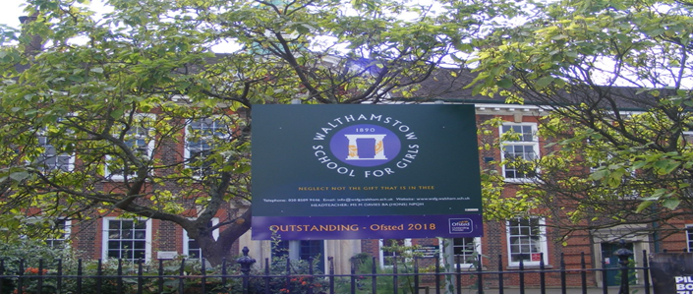

Part-time Evening and Weekend Receptionist
Scale 3
15 hours per week / 52 weeks per year
Weekdays 4.00pm-6.00pm
Saturdays 9.00am- 12 noon
To start as soon as possible


Welcome letter from Helen Marriott, Headteacher

November 2021
Dear Applicant
I am delighted that you are considering applying for the role of Part-time Evening and Weekend Receptionist at Walthamstow School for Girls. As the newly-appointed Headteacher in January this year, I consider it a privilege to lead staff and students in this exceptional school where we are passionate about education being a vehicle for promoting equality for all and where our mission is to empower young women to become leaders of the future.
Walthamstow School for Girls is a high achieving, oversubscribed, diverse school which is regularly in the top 10% nationally for progress, significantly above the national average in all key indicators, and is at the centre of the vibrant local community of Waltham Forest (the first London Borough of Culture). We have an ambition to become ‘world class’ and a commitment to work with other professionals both locally, nationally and internationally, through our Erasmus links. We won the national High Aspiration Award for the progress made by disadvantaged students and have won SSAT Achievement and Progress awards annually since 2014. We have been awarded the SSAT Exceptional Education standard twice; in 2017, for Leadership through Moral Purpose, and, in 2018, for Systems: use of assessment, data, policies and monitoring to support teaching and learning. We were awarded Teaching School and National Support School Status in September 2017. In June 2018, following a Section 8 inspection, we were awarded an Ofsted ‘outstanding’ judgement in all categories.
Our students are ambitious and hard-working; they embrace the range of opportunities offered to them both during and beyond the school day. This is highlighted not only by our exceptional examination results but also by the maturity of the girls, their sense of responsibility, community and fun. They are a delight to work with.
We offer excellent facilities to both staff and students. Our acclaimed architect designed site is an oasis of green and a pleasure to work in. It is well served by transport connections, being just ten minutes’ walk away from Walthamstow Central tube and overground station and five minutes’ walk from the popular Walthamstow ‘village’, and creative and restaurant quarter. We pride ourselves on working hard to retain our role as an important part of the local community. Examples of this commitment can be seen in our weekly Greensheets. Our staff are inclusive and friendly, with regular social and wellbeing events as well as charity fundraising.
We are committed to Safer Recruitment practices and procedures and shortlisted applicants will be questioned about their commitment to the safeguarding of young people. The successful candidate will be subject to an enhanced DBS clearance.

Thank you for taking an interest in this position. I do hope that having read more about the school you will decide to apply for the post. I look forward to receiving your application. Please note that it will not be possible to give feedback to unsuccessful applicants, other than those called for interview. Thank you for your understanding and good luck with your career in education.
Helen Marriott
Headteacher MA NPQH

About Walthamstow School for Girls

History

In January 1890, a circular stated that a “school for girls” was to be opened in Walthamstow. Miss Hewett was appointed as the first Headmistress and remained until she retired in 1924. There were 49 girls, whose ages ranged from 7-16 years. At this time there were only five teachers, two of whom were graduates.
Our original building was in West Avenue Road and when student numbers grew the school moved to Church Hill House, where a church now stands. It was in September 1913 that 243 girls came to the present building with the Greek Amphitheatre being added in the 1920s. In January 2010 our most recent refurbishment and rebuilding work was completed as part of the Building Schools for the Future Programme. This work has given us the unique blend of traditional and state of the art facilities that we currently enjoy at our school.
Our school in 2020
Walthamstow School for Girls is a high achieving, oversubscribed, diverse school which is regularly in the top 10% nationally for progress, significantly above the national average in all key indicators at Key Stage 4, and is at the centre of the vibrant local community of Waltham Forest (the 2019 and first London Borough of Culture). Our most recent results can be found on our website.
We have an ambition to become ‘world class’ and a commitment to work with other professionals both locally, nationally and internationally, through our Erasmus links. We won the national High Aspiration Award for the progress made by disadvantaged students in 2015 and have won SSAT Achievement and Progress awards annually since 2014.
We have been awarded the SSAT Exceptional Education standard twice; in 2017, for Leadership through Moral Purpose, and, in 2018, for Systems: use of assessment, data, policies and monitoring to support teaching and learning. We were awarded Teaching School and National Support School Status in July 2017. In June 2018, following a Section 8 inspection, we were awarded an ‘outstanding’ judgement in all categories.
“Middle Leaders are exceptional and collaborate well to share best practice. They drive their teams with energy and enthusiasm. They share the strong moral purpose of the Headteacher to ensure that no pupil is left behind. As a result, outcomes for pupils are outstanding, giving them essential life chances.” Ofsted 2018.
Students and staff
Every one of our 900 students is valued equally as an individual with different gifts and talents, reflecting our commitment to the school motto “Neglect not the gift that is in thee”. We offer strong pastoral support and regular monitoring, target setting and dialogue with students and parents/carers.
Our students are encouraged to express themselves, to be creative, to have high aspirations and to challenge stereotypes. There is a strongly ethos of equality at this school.
Our students are also ambitious and hard-working; they embrace the range of opportunities offered to them both during and beyond the school day. This is highlighted not only by our exceptional examination results but also by the maturity of the girls, their sense of responsibility, community and fun. They are a delight to work with.
One of the school’s strengths is the quality of the staff we are able to attract and keep. Our teachers ensure lessons are stimulating and challenging. Students work with enthusiasm and interest in classrooms where there is a calm atmosphere suitable for learning. The broad and balanced curriculum ensures that all students are extremely well equipped to continue their education.
Our environment

We offer excellent facilities to both staff and students. Our acclaimed architect designed buildings and facilities make a stunning learning and working environment. Our £18 million rebuild project, completed in 2010, dramatically extended and enhanced our accommodation. We have state-of-the-art facilities in science, technology and performing arts, as well as a fantastic dining hall, two assembly halls and social areas.
Situated in beautiful landscaped grounds, the school’s outside space encourages play and creativity as well as quiet reflection and study. Unusually for a London school, our buildings are surrounded by mature trees and lawns, a pond area and our Greek amphitheatre. We have an allotment area which invites students to learn how to grow fruit and vegetables, some of which are then used by our chef.
Our site is an oasis of green and a pleasure to work in. It is well served by transport connections, being just ten minutes’ walk away from Walthamstow Central tube and rail station and five minutes’ walk from the popular Walthamstow ‘village’, creative and restaurant quarter. We pride ourselves on working hard to retain our role as an important part of the local community. Examples of this commitment can be seen in our weekly Greensheets. Our staff are inclusive and friendly, with regular social and wellbeing events as well as charity fundraising.
Educating and empowering young women
Our role is to educate tomorrow’s women to be confident, articulate and able to discuss and debate intelligently. Through a range of activities and opportunities, students are helped to develop their leadership qualities, their sense of community and global responsibility as citizens of the world in line with our G.R.E.E.N. values.



Our G.R.E.E.N. Vision

The G.R.E.E.N. values
 | The value GROWTH is based on the work by Carol Dweck on growth mindset. Having a growth mindset encourages the belief that we can all improve at whatever we put our minds to with practice and perseverance. It encourages learning, effort and stickability. It also promotes the importance of reflection and criticism as tools to move us forward.
 | The value RESILIENCE represents the notion that, on any learning journey, there will be obstacles. With RESILIENCE and perseverance, these obstacles can be overcome and the final goal more rewarding. The key is not to be fearful of these obstacles and to accept that mistakes and challenges are an important part of learning. The learning line is an effective symbol for resilience and for assessment for learning.
 | The value ENERGY is the centre of our vision. It encourages focus and enthusiasm from everyone. This ENERGY could be represented in the attitude of students as well as in staff morale, parent and governor involvement. It promotes positivity and supports all of the other G.R.E.E.N. values.
 | The value EMPATHY promotes community spirit in many dimensions. It signifies self-awareness as well as respect for each other despite our differences. In addition to this, it illustrates that none of us are alone on our learning journey and that, through collaboration, success can be greater.
 | The value NEWNESS is vital in an ever changing world. This encourages us to be open to new ideas, techniques, technologies and challenges. It encourages us all to step out of our comfort zones as this is where the deepest learning and the greatest success can be achieved.

What staff value about the school

- This school feels safe, kind and caring. We are not driven by results – we seem to be driven to produce fabulous young women
- Ethos of the school, supportive colleagues and strong management with compassion
“There are very strong working relationships between staff and pupils based on mutual trust and respect.” Ofsted 2018
- I value the ethos of hard work in the students and how the school promotes kindness, tolerance and maturity amongst the students
- Atmosphere of diversity, respect and inclusion
- Freedom to teach in a range of styles

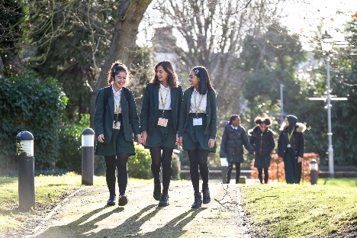

Job Description

Job title: Part-Time Evenings and Weekend Receptionist
Reporting to: Administration Manager / Business Manager
Line management of: N/A
Liaising with: Leadership Team (LT), all Teachers and support staff, governors, hirers of school facilities and visitors
Working time: 15 hours per week, 52 weeks per year (Weekdays 4pm-6pm)
(Saturdays 9am-12pm)
Salary / Grade: Scale 3
Disclosure: Enhanced

Core Purpose | - To manage the school reception area, ensuring that all visitors are welcomed in a courteous, friendly and professional manner  - To ensure queries from parents and carers related to evening enrichment sessions are managed and dealt with  - To assist with administering our hirers and their participants during various lettings during the evenings and on weekends  - To be the first point of contact and responsible for maintaining and raising the public image of the school in relation to the wider school community
Main Reception duties | - To manage the school reception area, greeting all visitors to the school efficiently and to assist them with their enquiries  - To be responsible for ensuring that visitors entering the school are signed in using the approved procedure and to be responsible for checking their ID and DBS information, issuing the correct visitor lanyard to confirm that the required checks have been completed  - To ensure parental concerns regarding the whereabouts of their daughter after school are followed up with the onsite SLT colleagues and Lettings Officer  - To work in partnership with the Lettings Officer and/or Site Team to ensure all evening and weekend lettings function smoothly  - To ensure that the Reception area is kept clean, tidy and up to date with the most recent school information documents  - To be responsible for allowing entry for registered hirers and their participants during lettings sessions in the evenings and weekends  - To deal with any student issues efficiently and effectively
Administration duties | - To provide general administrative support across the school under the direction of the Administration Manager  - To operate the telephone system, answering calls within the school’s agreed quality standards, filtering calls, directing calls, taking and communicating detailed messages  - To be responsible for checking the main school email account and distributing email correspondence to the relevant staff, with copies to the Leadership Team and other Middle Leaders, as outlined in the agreed procedures  - To support in the input of student data ensuring that the database is up to date and accurate at all time
Other duties | - To administer first aid on site if necessary and in accordance with current guidelines, including escorting students to hospital in the event of an emergency under the Headteacher’s direction
School Ethos | - To play a full part in the life of the school community, to support its distinctive aims and ethos and to encourage staff and students to follow this example  - To be flexible and work according to needs which may involve assisting other areas which are commensurate with the grading of the post
Whole School Contribution | - Be aware and comply with policies and procedures relating to Safeguarding, Equal Opportunities, Behaviour for Learning, Health and Safety, Data Protection and confidentiality, reporting all concerns to an appropriate person  - To promote actively the school’s policies  - To continue professional development  - To comply with the school’s Health and Safety policy

Whilst every effort has been made to explain the main duties and responsibilities of the post, each individual task undertaken may not be identified.

The school will endeavour to make any necessary reasonable adjustments to the job and the working environment to enable access to employment opportunities for disabled job applicants or continued employment for any employee who develops a disabling condition.
This job description is current at the date below but will be reviewed on an annual basis and, following consultation with you, may be changed to reflect or anticipate changes in the job requirements which are commensurate with the job title and grade.
The Governing Body and the Local Authority are committed to safeguarding and promoting the welfare of children and young people. The Headteacher must ensure that the highest priority is given to following the latest national guidance and regulations on safeguarding and child protection. This role is subject to an enhanced DBS check.

November 2021

This school is committed to safeguarding and promoting the welfare of children and young people and expects all staff and volunteers to share this commitment.

Person Specification

 | Criteria | Essential | Desirable |  | Assessed by application | Assessed by selection process
 | Qualifications
1 | Good general standard of education | / |  |  | /
2 | First Aid qualification |  | / |  | /
 | Experience
3 | Relevant work experience | / |  |  | / | /
4 | Experience of the use of a wide range of computer software including spreadsheets and data bases, including SIMS | / |  |  | / | /
5 | Experience of working on own initiative |  | / |  | /
6 | Knowledge \ experience of working in the education sector and/or schools |  | / |  | /
 | Special abilities and aptitudes
7 | Flexibility and ability to work as part of, and to contribute to, the school administration team | / |  |  | / | /
8 | Excellent interpersonal skills to enable positive outcomes when dealing with parents/carers, students, colleagues, governors, LA representatives and other outside agencies | / |  |  | / | /
9 | Ability to deal sensitively and in confidence with a wide range of issues relating to working practices | / |  |  | / | /
10 | Ability to work effectively under pressure and to manage own workload | / |  |  |  | /
11 | Ability to communicate effectively at all levels both verbally and in writing | / |  |  | / | /
12 | Ability to type quickly and accurately | / |  |  | / | /
13 | Ability to work methodically, ensuring attention to detail | /
14 | Numeracy skills | /
 | Other
15 | Commitment to the LA’s Equal Opportunities Policy and acceptance of their responsibility for its practical application | / |  |  | / | /

Disqualifying Factors
Indication of sexist, racist or anti-disabiliy attitudes or any other inconsistent with the Local Authority’s Equal Opportunities Policy. This school is committed to safeguarding and promoting the welfare of children and young people and expects all staff and volunteers to share this commitment.

Staff Benefits

Outlined below are some of the additional benefits available to staff working at Walthamstow School for Girls.

Cycle 2 work scheme
This benefit offers staff the opportunity to make tax and national insurance savings whilst keeping fit at the same time.
Commitment to CPD
We actively encourage CPD to all staff. We regularly provide whole school CPD as part of the school calendar, as well as opportunities for individual CPD requests.
“I have been given some fantastic CPD opportunities with an amazing amount of training. My personal knowledge and confidence has increased immensely.”

Eye Tests
All staff using computer equipment should have eye and eyesight checks at regular intervals. Eyesight testing should also happen where staff experience visual difficulties, which may reasonably be considered to be caused by computer work. Staff working within schools in the London Borough of
Waltham Forest may be entitled to reimbursement of some costs associated with vision testing and the frames and lenses needed to enable them to work safely on display screen equipment.

Staff Wellbeing
As part of our CPD for staff we include session related to staff wellbeing. There are also opportunities for staff to participate in various activities as individuals.

At Walthamstow School for Girls we also offer a staff running club, Badminton club, Boxfit exercise sessions, yoga and the London Club (historical walks around London).
“Since joining WSFG I have felt totally reinvigorated and I am excited to teach again. This is undoubtedly because the atmosphere in school is a very positive one.”

Workplace Options - Employee Assistance Provider

A confidential counselling, help and information service is provided for all those employed by Waltham Forest and is available free of charge 24 hours a day, every day of the year. This service can help with a range of problems from practical everyday matters to sensitive and emotional issues. For further information please call 0800 328 1437 or contact: www.employeeassistance.org.uk

Non-meeting weeks
There are designated non-meeting weeks throughout the year to support with reduced workload and and staff wellbeing.



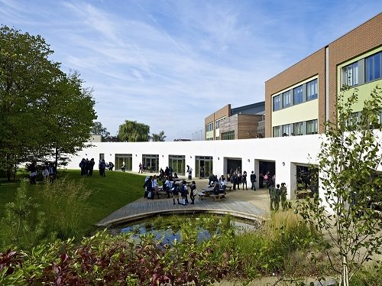

For further information about our school please visit our website: www.wsfg.waltham.sch.uk

