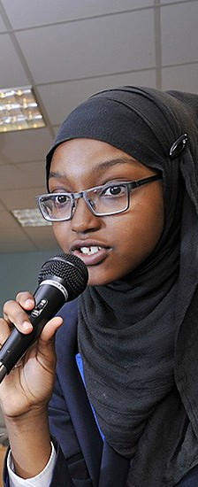

LAMMAS SCHOOL
Appointment of Head of Humanities
Main Scale + TLR1b (outer London)
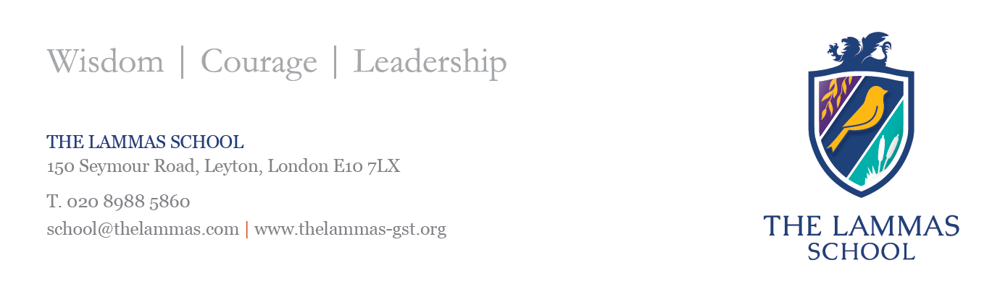


Proud Traditions | Wide Horizons | High Achievement


Contents

An Introduction to Lammas 3
The Benefits of Working at Lammas 4
Person Specification 5
The GST Family 6
How to Apply 7



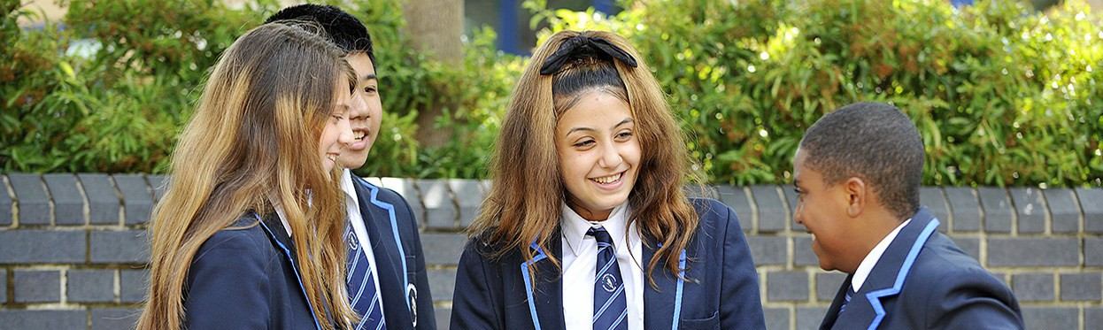
An introduction to Lammas School

Thank you for your interest in becoming part of our school community.

Lammas School is a secondary school with VI Form provision in Leyton, East London. We have been serving the community for 19 years since we opened in September 2001 and are proud of the impact we are making on the lives of our young people.

In December 2018, we were delighted to join the Griffin Schools Trust and are now part of a family of schools with a distinctive identity. Our closest partner schools are Riverley and Willow Brook, both of which are Outstanding and one of which is a shining example of ‘Griffin Great.’

We have a strong vision. Lammas is committed to providing an excellent and inspiring educational experience for all our students. To support this, Lammas School:
- raises aspirations, expectations and achievement for all students
- ensures students acquire the knowledge, skills and qualifications relevant to adult life and employment
- shows students how to think for themselves, to develop enquiring minds and become disciplined learners
- helps students to understand the world in which they live and their own responsibilities as members of our community and society
- broadens our students’ horizons through a range of academic, creative, sporting and musical activities within and beyond the classroom.

We are passionate about educating young people through a well-rounded approach built on rich extra-curricular programmes and high quality pastoral care as well as an inspiring curriculum, expertly taught.

Mark Bland
Head

The Benefits

Lammas School is committed to challenging educational and social disadvantage and aims to
instil in students the ability to think critically and creatively.

The experience of working for Lammas School, and The Griffin Schools Trust, is unique. You will receive challenge and support to become expert in your field, develop the highest-level leadership skills and benefit from the wisdom of an extended family of supportive colleagues. There are excellent opportunities to work with peers and senior Trust staff on elements of our secondary strategy, to engage in leadership training as well as join a research-based Masters Programme.

We engage in a wide variety of Proud Traditions and experiences, including The Griffin Sports Festival, Arts Festival and Science Symposium, which give our community an exceptional breadth of experience.

Lammas School is set within a mile of The Queen Elizabeth Olympic Park, overlooks the green space of Jubilee Park and is located in Waltham Forest, London’s first Borough of Culture, 2019.

Leyton is a truly multi-cultural East London community, with the vibrancy and opportunity
that brings. House prices have risen faster than in any other London borough, and better value can often be found in neighbouring areas, as illustrated below:

Chingford
Rental
1 bed - £900 - £1200
2 bed - £1200 - £1350
3 bed - £1500 - £1800

Purchase
1 bed - £185,000 - £300,000
2 bed - £280,000 - £400,000
3 bed - £475,000 - £600,000

Grays
Rental
1 bed - £700 - £900
2 bed - £825 - £1250
3 bed - £110 - £1350

Purchase
1 bed - £125,000 - £200,000
2 bed - £130,000 - £300,000
3 bed - £350,000 - £400,000

Ilford
Rental
1 bed - £950 - £1400
2 bed - £1200 - £1500
3 bed - £1300 - £1600

Purchase
1 bed - £200,000 - £260,000
2 bed - £270,000 - £350,000
3 bed - £300,000 - £500,000

Leytonstone
Rental
1 bed - £1100 - £1300
2 bed - £1200 £1500
3 bed - £1400 - £1750

Purchase
1 bed - £240,000 - £325,000
2 bed - £310,000 - £500,000
3 bed - £425,000 - £800,000

Romford
Rental
1 bed - £850 - £1200
2 bed - £1200 - £1400
3 bed - £1300 - £1700

Purchase
1 bed - £150,000 - £250,000
2 bed - £280,000 - £350,000
3 bed - £325,000 - £450,000

Person Specification

Great departmental leaders come from all sorts of backgrounds. You may have been in another career before teaching, you may currently be in an international school and
looking to return to the UK or teaching in the UK independent or maintained sector and looking for promotion.

We welcome applicants with at least five years’ teaching experience, who
  - are highly ambitious for their students
  - can communicate their enthusiasm for science
  - have the drive to build an outstanding department and team
  - can demonstrate a strong personal track record.

The department teaches History and Geography at GCSE and has a small and growing cohort of A level students.

Lammas School is one of the few schools in the area with a sixth form. Most are 11-16 and feed their post 16 students into a local sixth form college. We established the Sixth Form in 2015 and are still expanding our offer and increasing our stay-on rate. Our new Head of Humanities will have a major role to play in growing the strength of History and Geography in our developing Sixth Form and that, of course, will depend on the excitement and rigour generated in the lower years.



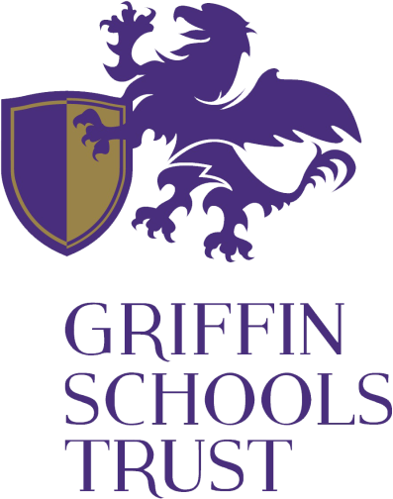


Bramford
West Midlands
Joined June 2013


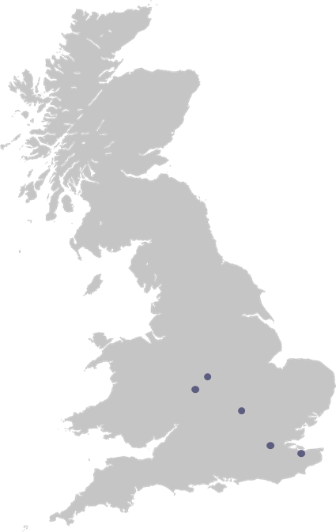Chivenor
West Midlands
Joined February 2014


Perry Wood
West Midlands
Joined December 2012


Nicholas Chamberlaine North Warwickshire
Joined September 2013


Park Lane
North Warwickshire
Joined November 2013


Race Leys
North Warwickshire
Joined September 2012

Lammas
East London Joined December 2018


Riverley East London
Joined November 2013


Willow Brook East London
Joined April 2015


Kingfisher Medway
Joined September 2013


Saxon Way Medway
Joined September 2013


Lordswood Medway
Joined November 2013

How to Apply

In these exceptional times we will do our best to show you the heart of Lammas so that you can get a sense of how well matched you may be to our professional community as a school and indeed as a Trust. Please look at our website (which is rather out-dated and in the process of a total re-build) and explore the Trust website as fully as you can ( www.griffinschoolstrust.org). You will see evidence of the shared life of the schools in the Trust in events such as the Science Symposium, the Arts Festival, the Sports Festival and Founders Day.

The Trust really is a family of schools which work closely together within and across phases and
geographical hubs. So in joining Lammas you do have good relationships with local authority schools and projects but you also have a strong working relationship with your peers in two secondary schools in Milton Keynes and North Warwickshire as well as day to day involvement with our two GST neighbour primaries, Willow Brook and Riverley, both outstanding and one a shining example of what a Griffin Great School looks and feels like. It is that journey to Griffin Great that informs our development planning.
Ofsted validates our progress within a defined national framework: it emphatically does not set our
agenda. Please read the attached Griffin Great descriptors very carefully because that is the culture and performance you will be helping us to build should you join us. Your research into Lammas
will help you see how far we have yet to travel. Ofsted judged us ‘Good’ in 2017 but we know we are some
way from Griffin Great.

Having researched sufficiently to decide to apply, please tell us in no more than two sides of A4 in 11 point
(1) why you want to join Lammas School as Head of Humanities and what you see as our challenges (2) why your personal track record matches or exceeds our requirements.

Please include a full cv with the names and direct contact details of two referees and the completed Safer Recruitment form. We will contact your referees before shortlisting. We may also have a phone call with you.

Completed applications should be addressed to Mark Bland and sent to jahmet@thelammas.com

The deadline for application is Monday 27 September 2021.

If you would like a confidential exploratory call once you have done initial research into Lammas School and the Griffin Schools Trust, please email jahmet@thelammas.com who will make an appointment.

Lammas School is an equal opportunities employer committed to safeguarding our students and working in partnership with our local community. We treat people equally regardless of gender, race, disability or sexual orientation and are committed to meet the requirements of the Equalities
Act and other relevant legislation.
7

