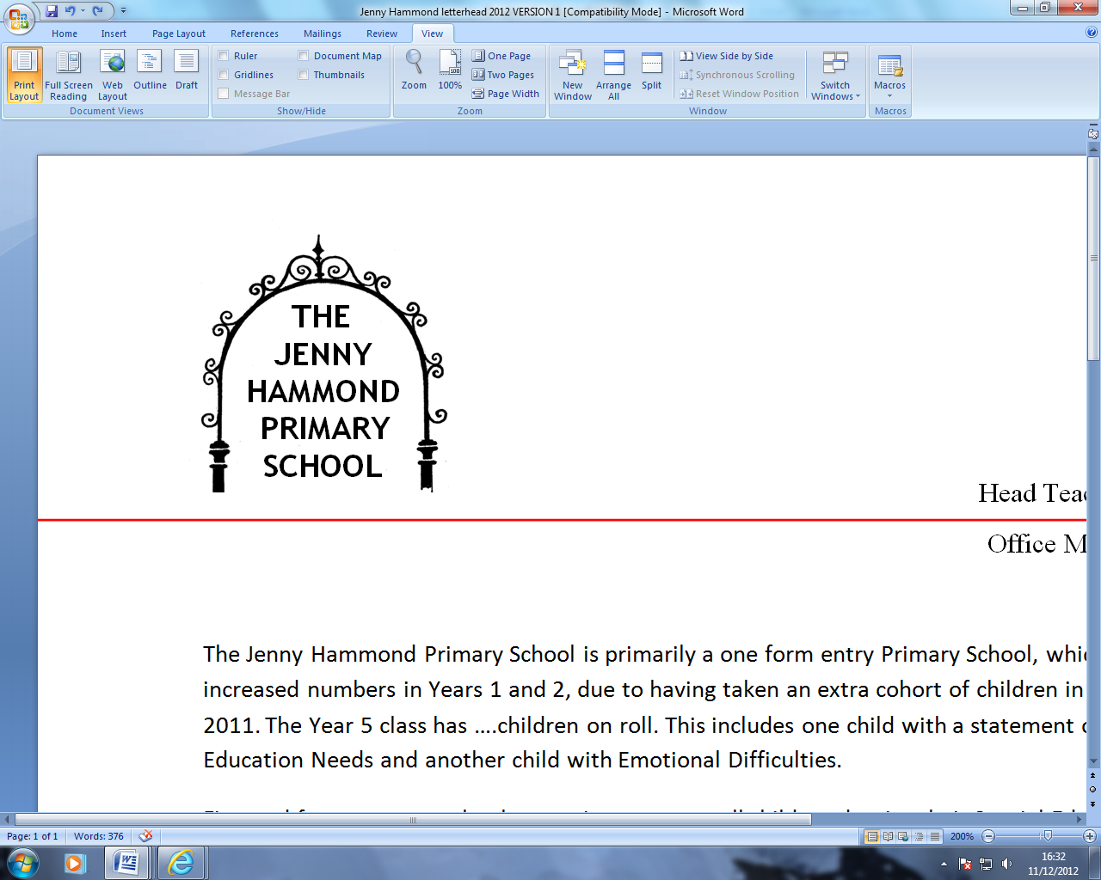
PERSON SPECIFICATION & ASSESSMENT

Administration Assistant Level 1

JOB REQUIREMENTS | Essential | Desirable | Method of Assessment  I/T/A

Qualifications
GCSE 4 - 9 or NVQ Level 2 minimum English and Maths or equivalent. |  |  | A
Good written and verbal communication skills. |  |  | A
Good IT competency in Microsoft office packages. |  |  | A/T
A commitment to take part in any relevant training as required for the role |  |  | A/I

Experience
Experience of using computerised information system in an administrative environment. |  |  | A/I
Experience of using Microsoft Office packages. |  |  | A/I/T
Experience of using SIMS or comparable database. |  |  | A/I
Office experience preferably in a school environment. |  |  | A/I
Experience of working effectively without close supervision when necessary |  |  | A/I/T

Skills, knowledge and Understanding
Good interpersonal skills. |  |  | I
Ability to communicate politely and efficiently with a range of service users. |  |  | A/I
Ability to act with discretion and maintaining confidentiality |  |  | A/I
Ability to work successfully as a team member establishing effective working relationships and flexible working practices within the school. |  |  | A/I
Ability to work under pressure in a constantly changing and demanding environment. |  |  | A/I/T
Ability to maintain accurate records and filing systems. |  |  | A/I
Proven literacy, numeracy and communication skills including being able to respond to staff, parents/carers, governors, pupils outside agencies and the local authority. |  |  | A/I/T
Accurate keyboard skills – word processing and typing |  |  | A/I/T
Accurate and attends to detail |  |  | A/T
Good organisational and time management skills to meet demands and deadlines of the role. |  |  | A/I/T
Ability to work flexibly. |  |  | A/I
Ability to relate to adults and children of all ethnic and cultural groups. |  |  | A/I
Commitment to educational inclusion, equal opportunities and to safeguarding. |  |  | A/I

Other Requirements
Disqualifying factor: Indication of sexist, racist or anti-disability attitudes or any other attitudes inconsistent with the school’s Equal Opportunity Policy. |  |  | A/I
A commitment to on-going personal development and willingness to undertake appropriate training |  |  | A/I
Appointment to the post is subject to a satisfactory enhanced DBS check |  |  | A/I
Evidence of commitment to safeguarding and protecting the welfare of children |  |  | A/I
This post is exempt from section 4(2) of the Rehabilitation of Offenders Act, 1974, as the duties give you access to persons who are under the age of 18. Applicants are not entitled to withhold information about convictions, which would be regarded as spent for other purposes. |  |  | A/I

I - Interview
T – Task
A – Application Form

