
WALTHAMSTOW SCHOOL FOR GIRLS
“Neglect not the gift that is in me”

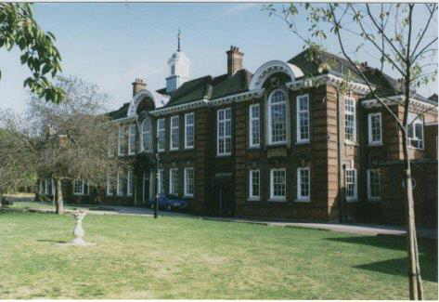

Information for applicants for the post of
Cover Administrator / Administrative Assistant
October 2019



October 2019

Dear Applicant
Thank you for requesting an application pack for the post of Cover Administrator / Administrative Assistant.
Walthamstow School for Girls is a high achieving, oversubscribed, diverse school which is regularly in the top 5% nationally for progress and the top 10% nationally for attainment and is at the centre of the vibrant local community of Waltham Forest (the first London borough of culture). We have an ambition to become ‘world class’ and a commitment to work with other professionals both locally, nationally and internationally, through our Erasmus links. We won the national High Aspiration Award for the progress made by disadvantaged students and have won SSAT Achievement and Progress awards annually since 2014. We have been awarded the SSAT Exceptional Education standard twice; in 2017, for Leadership through Moral Purpose, and, in 2018, for Systems: use of assessment, data, policies and monitoring to support teaching and learning. We were awarded Teaching School and National Support School Status in September 2017. In June 2018, following a Section 8 inspection, we were awarded an ‘outstanding’ judgement.
Our students are ambitious and hard-working; they embrace the range of opportunities offered to them both during and beyond the school day. This is highlighted not only by our exceptional examination results but also by the maturity of the girls, their sense of responsibility, community and fun. They are a delight to work with.
We offer excellent facilities to both staff and students. Our acclaimed architect designed site is an oasis of green and a pleasure to work in. It is well served by transport connections, being just ten minutes’ walk away from Walthamstow Central tube and overground station and five minutes’ walk from the popular Walthamstow ‘village’, and creative and restaurant quarter. We pride ourselves on working hard to retain our role as an important part of the local community. Examples of this commitment can be seen in our weekly Greensheets. Our staff are inclusive and friendly, with regular social and wellbeing events as well as charity fundraising.
We are committed to Safer Recruitment practices and procedures and shortlisted applicants will be questioned about their commitment to the safeguarding of young people. The successful candidate will be subject to an enhanced DBS clearance.
Thank you for taking an interest in this position. I do hope that having read more about the school you will decide to apply for the post. I look forward to receiving your application. Please note that it will not be possible to give feedback to unsuccessful applicants, other than those called for interview. Thank you for your understanding and good luck with your career in education.
Ms Meryl Davies
Headteacher, NPQH, NLE



The History of Walthamstow School for Girls
In January 1890, a circular stated that a “school for girls” was to be opened. Walthamstow was described as a pleasant suburb on the borders of Epping Forest. Hoe Street was almost a country road, with a few houses on either side and meadows in which were sheep, cattle, hawthorn and wild roses.
Miss Hewett was the first Headmistress, at the age of 27 until she retired in 1924. There were 49 girls, whose ages ranged from 7-16 years. At this time there were only five teachers, two of whom were graduates. The School’s original Staff Book gives details of the first one hundred teachers. Of them 30 remained at the school for ten years or more, 22 giving over twenty years’ service. Until 1944 all the teachers were women and not married.
The original building was in West Avenue Road and when the numbers grew the school moved to Church Hill House, where a church now stands. At this time there were also boys up to the age of 13 years at the school. It was in September 1913 that 243 girls came into the present building with the Greek Theatre being added in the 1920s. However in July 2008 the whole school moved off site for a period of four school terms to facilitate the building and refurbishment programme that has resulted in the unique blend of traditional and state of the art facilities found at the school today.
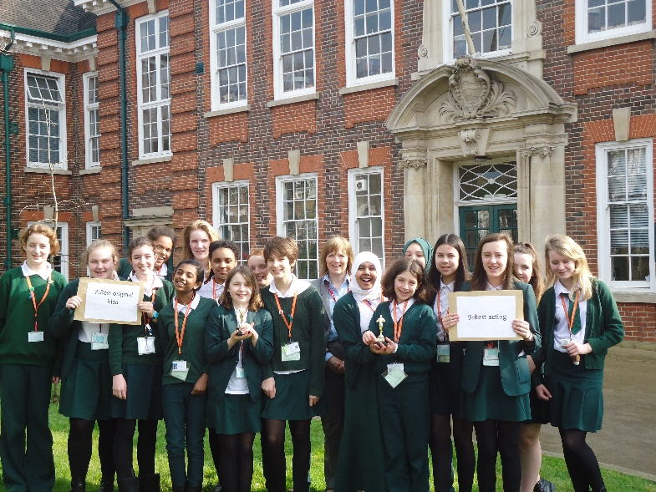
Walthamstow School for Girls is a place of high achievement. Effective teaching and learning are at the heart of our school. The school motto “Neglect not the gift that is in thee” underpins all the school’s work. Every girl is expected, encouraged and supported to achieve her very best academically and our pastoral system supports our students’ academic and social experiences.
Our role is to educate tomorrow’s women through a range of activities and opportunities to be confident, secure and happy individuals as they prepare for further education, careers and future lives.



Cover Administrator / Administration Assistant
Required as soon as possible
Salary range: Scale 4 / 5 (£22,377- £26,274) pro rata
Hours: 36 hours per week, 48 weeks per year (7.30am morning start)

Walthamstow School for Girls is a vibrant and successful multicultural school. Our students are committed and positive learners who benefit from a purposeful and dynamic learning environment.

We are looking for an experienced, well organised and highly motivated Administrative Assistant. Working in a busy school office the post holder will be responsible for the management of the teaching cover requirements as well as supporting the Administration Manager with general administrative duties.

The successful applicant will have excellent verbal and written communication and ICT skills, experience of using SIMS would be an advantage. They must have the ability to be self-motivated and flexible with a pleasant and positive attitude. They will also be expected to act as a first aider within the school.

An application form and further details can be downloaded from the school website www.wsfg.waltham.sch.uk. Completed application forms should be returned by email to Mandy Madhani, HR Manager, m.madhani@wsfg.waltham.sch.uk. Please note CVs will not be accepted.
Closing date: Wednesday 6th November 2019 (12 noon)
Interview date: Week Commencing Monday 11th November 2019

Walthamstow School for Girls is committed to Equal Opportunities and to Safer Recruitment practices and procedures.

Walthamstow School for Girls is committed to safeguarding and protecting the welfare of children and young people. The successful candidate applicant will be required to undertake an Enhanced DBS Disclosure.

WALTHAMSTOW SCHOOL FOR GIRLS
Job Description

JOB TITLE: Cover Officer/Administrative Assistant
(48 weeks p.a, 36 hours per week)

GRADE: Scale 4 / 5

LINE MANAGER: Administrative Manager

REPORTING TO: Deputy Headteacher (KS4)

JOB PURPOSE
To be responsible for the management of the teaching cover requirements ensuring the cost effective use of supply. Liaise with the Deputy Head for Cover to manage the staff cover system to ensure continuity of teaching and learning. Ensuring that safeguarding requirements and other relevant regulations are in place and adhered to including the completion and recording of necessary checks.
To be part of a team to carry out a range of administrative, reprographic and reception duties. At all times to work to raise the public image of the school and provide a welcoming, courteous reception to all school visitors.
MAIN DUTIES
Cover Administration
- To be in school early each morning to collect daily messages from the cover phone line.

- Responsible for allocating cover effectively and efficiently to enable the school to operate with minimum disruption to students. Liaising with the Deputy Head for Cover to maximise supply usage and minimise cost to the school.

- To be responsible for the administration of daily cover for staff absences and the maintenance of appropriate records.

- Responsible for providing staff with cover details at the start of the day and when emergencies occur.

- To liaise with supply agencies to ensure value for money and appropriate cover for absence. Ensuring only appropriately qualified supply staff are booked to cover absences and temporary vacancies.
- To be responsible for the induction and support of supply teachers, ensuring they are met on arrival and provided with clear instructions and registers. Provide a Supply Information folder, and ensure they have all the work and resources they need for a successful day. Liaise with Heads of Faculty as necessary.

- Be aware of the effectiveness of supply staff as per school policies and procedures informing SLT of any concerns and tactfully refer concerns to the agency if appropriate.

- To maintain records of supply staff used and agency bookings.

- To ensure that supply teachers are able to access the cover work set by absent staff/HoFs as required (electronically or hard copy).

- To be responsible for the checking and authorising of supply teacher timesheets and processing the invoices. Ensuring the correct Framework fees have been charged.

- To ensure that cover is distributed fairly to all staff and provide regular reports in respect of transparency of cover for the leadership team. Maintain records on covers completed by individual staff to ensure the School Policy for cover is adhered to.

- To liaise with Heads of Faculty and SLT with regards to supply teachers who are on a short to long term contract, ensuring that appropriate feedback is obtained from the Faculty and fed back to the agency.

- To collate any issues with regards to the quality of cover work that has been set and inform Heads of Faculty when issues have arisen.

- To attend weekly educational visits meeting to advise the Educational Visits Coordinator of the cover implications in respect of all trips and events in school and to implement cover accordingly.

- To liaise with the Assistant Headteacher and the Examinations and Assessment Manager regarding the exam timetables and subsequent cover and room changes required.

- To input staff absences onto SIMS, keeping the records up to date at all times.

- To be responsible for ensuring that the correct proof of identification and DBS information in respect of supply staff is received and checked and passed to the Human Resources Manager on a daily basis.

- To be responsible for raising any concerns regarding the vetting sheets obtained from supply agencies with the Human Resource Manager as a matter of urgency.

- To feedback to the Deputy Headteacher any issues in respect of the quality of cover lessons.

- Produce accurate, complex reports around cover statistics

Additional Administrative duties:
- To provide general administrative support under the direction of the Administrative Manager supporting relevant activities outlined in the Single Status Administrative Assistant’s Level 3 Job description.

- To assist the Administrative Manager with whole school events eg Community Party and Presentation Evening

- Responsible for using the Docmail system to send large mail outs, eg Governor Elections and letters to new Year 7 parents.

- To assist at reception, ensuring that all visitors are welcomed in a polite, friendly and efficient manner and provide hospitality as required.

- To deal with all phone calls in a polite and efficient manner

6. To help train new members of Front Office staff so they become effective members of the team
7. To deal with student issues efficiently and effectively.

8. To be responsible for checking levels of office stationary and ordering replacements as
required.

9. To assist with Human Resources and recruitment administration as required by the
Human Resources Manager.

10. To assist with in the input of student data.

11. To provide support for the Media Resources Officer when required.

12. To produce detention letters and upkeep the detention data base.

13. Ensuring the SPL filing is up to date

14. To be responsible for supplying refreshments as necessary.

Other requirements
- Be aware of and comply with policies and procedures relating to child protection, equal opportunities, behaviour for learning, health, safety and security, confidentiality and data protection, reporting all concerns to an appropriate person.

- Contribute to the overall ethos/work/aims of the school.

- To administer first aid on site if necessary and in accordance with current guidelines, including responsibility for the accident book, forms and escorting students to hospital in the event of an emergency under the Headteacher’s direction.

- There is an expectation to attend all key school events out of hours as detailed in the school calendar e.g. Open Evenings, all Faculty and Staff Meetings and relevant twilight Inset sessions.

- To be flexible and work according to needs which may involve assisting other areas which are commensurate with the grading of the post.

This school is committed to safeguarding and promoting the welfare of children and young people and expects all staff and volunteers to share this commitment.

October 2019

Walthamstow School for Girls
Cover Administrator / Administration Assistant
Person Specification

Experience
- Relevant work experience Essential
- Experience of the use of SIMS | Desirable
- Experience of working on own initiative. | Essential
- Experience of the use of a wide range of computer software (e.g. word processing, spreadsheets, databases). | Essential
- Knowledge/experience of Education sector and/or schools. | Desirable
Special abilities / aptitudes
- Flexibility and ability to work as part of and to contribute to the school administrative team. | Essential
- Interpersonal skills - dealing with parents, students, colleagues and outside agencies. | Essential
- Ability to deal sensitively and in confidence with a wide range of issues relating to working practices. | Essential
- Ability to communicate effectively at all levels both verbally and in writing. | Essential
- Ability to work effectively under pressure and to manage own workload. | Essential
- Ability to type quickly and accurately. | Essential
- Ability to work methodically, ensuring attention to detail. | Essential
- Numeracy skills. | Essential
Other job specific requirements
- Commitment to the Authority’s Equal Opportunities Policy and acceptance of their responsibility for its practical application. | Essential
Education and Training
- Good General Standard of Education. | Essential

Disqualifying Factors
Indication of sexist, racist or anti-disability attitudes or any other inconsistent with the Authority’s Equal Opportunities Policy.

October 2019

Staff Benefits
Outlined below are some of the additional benefits available to staff working at Walthamstow School for Girls.
Cycle 2 work scheme
This benefit offers staff the opportunity to make tax and national insurance savings whilst keeping fit at the same time.
Commitment to CPD
We actively encourage CPD to all staff. We regularly provide whole school CPD as part of the school calendar as well as supporting individual CPD requests.
Eye Tests
All staff using computer equipment should have eye and eyesight tests at regular intervals. Eyesight testing should also happen where staff experience visual difficulties, which may reasonably be considered to be caused by computer work.

Staff Wellbeing
As part of our CPD for staff we include sessions related to staff wellbeing. These include The Walthamstow School for Girls Running Club, Badminton, Box fit exercise sessions, yoga and the London Club (historical walks around London).

Workplace Options - Employee Assistance provider
A confidential counselling, help and information service is provided for all employees of LBWF and is available free of charge 24 hours a day, every day of the year. Counselling is offered on the telephone or in a face-to-face setting, in locations close to your work or your home. This service can help with a range of problems from practical everyday matters to sensitive and emotional issues. Please visit http://www.workplaceoptions.co.uk for further information.

