
WALTHAMSTOW SCHOOL FOR GIRLS
“Neglect not the gift that is in me”

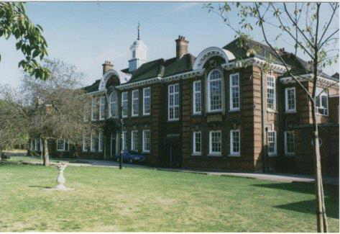

Information for applicants for the post of:
Temporary Learning Mentor
(To cover a period of maternity leave)
Required December 2019



October 2019

Dear Applicant
Thank you for requesting an application pack for the post of Temporary Learning Mentor.
Walthamstow School for Girls is a high achieving, oversubscribed, diverse school which is regularly in the top 5% nationally for progress and the top 10% nationally for attainment and is at the centre of the vibrant local community of Waltham Forest (the first London borough of culture). We have an ambition to become ‘world class’ and a commitment to work with other professionals both locally, nationally and internationally, through our Erasmus links. We won the national High Aspiration Award for the progress made by disadvantaged students and have won SSAT Achievement and Progress awards annually since 2014. We have been awarded the SSAT Exceptional Education standard twice; in 2017, for Leadership through Moral Purpose, and, in 2018, for Systems: use of assessment, data, policies and monitoring to support teaching and learning. We were awarded Teaching School and National Support School Status in September 2017. In June 2018, following a Section 8 inspection, we were awarded an ‘outstanding’ judgement.
Our students are ambitious and hard-working; they embrace the range of opportunities offered to them both during and beyond the school day. This is highlighted not only by our exceptional examination results but also by the maturity of the girls, their sense of responsibility, community and fun. They are a delight to work with.
We offer excellent facilities to both staff and students. Our acclaimed architect designed site is an oasis of green and a pleasure to work in. It is well served by transport connections, being just ten minutes’ walk away from Walthamstow Central tube and overground station and five minutes’ walk from the popular Walthamstow ‘village’, and creative and restaurant quarter. We pride ourselves on working hard to retain our role as an important part of the local community. Examples of this commitment can be seen in our weekly Greensheets. Our staff are inclusive and friendly, with regular social and wellbeing events as well as charity fundraising.
We are committed to Safer Recruitment practices and procedures and shortlisted applicants will be questioned about their commitment to the safeguarding of young people. The successful candidate will be subject to an enhanced DBS clearance.
Thank you for taking an interest in this position. I do hope that having read more about the school you will decide to apply for the post. I look forward to receiving your application. Please note that it will not be possible to give feedback to unsuccessful applicants, other than those called for interview. Thank you for your understanding and good luck with your career in education.
Ms Meryl Davies
Headteacher, NPQH, NLE



The History of Walthamstow School for Girls
In January 1890, a circular stated that a “school for girls” was to be opened. Walthamstow was described as a pleasant suburb on the borders of Epping Forest. Hoe Street was almost a country road, with a few houses on either side and meadows in which were sheep, cattle, hawthorn and wild roses.
Miss Hewett was the first Headmistress, at the age of 27 until she retired in 1924. There were 49 girls, whose ages ranged from 7-16 years. At this time there were only five teachers, two of whom were graduates. The School’s original Staff Book gives details of the first one hundred teachers. Of them 30 remained at the school for ten years or more, 22 giving over twenty years’ service. Until 1944 all the teachers were women and not married.
The original building was in West Avenue Road and when the numbers grew the school moved to Church Hill House, where a church now stands. At this time there were also boys up to the age of 13 years at the school. It was in September 1913 that 243 girls came into the present building with the Greek Theatre being added in the 1920s. However in July 2008 the whole school moved off site for a period of four school terms to facilitate the building and refurbishment programme that has resulted in the unique blend of traditional and state of the art facilities found at the school today.
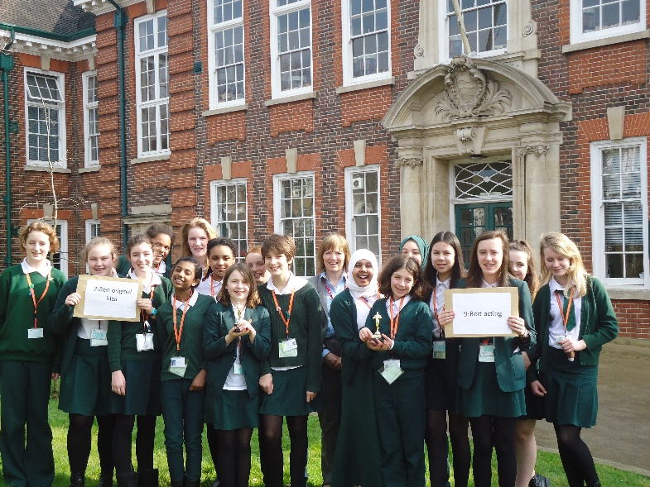
Walthamstow School for Girls is a place of high achievement. Effective teaching and learning are at the heart of our school. The school motto “Neglect not the gift that is in thee” underpins all the school’s work. Every girl is expected, encouraged and supported to achieve her very best academically and our pastoral system supports our students’ academic and social experiences.
Our role is to educate tomorrow’s women through a range of activities and opportunities to be confident, secure and happy individuals as they prepare for further education, careers and future lives.



WALTHAMSTOW SCHOOL FOR GIRLS

Temporary Learning Mentor

Required December 2019 to cover a period of maternity leave
3 days per week
(21.6 hours per week)
Scale 6
£27,228 - £28,725 per annum (pro rata)

We are looking to appoint an experienced Learning Mentor to work with students individually and in small groups, helping them to overcome barriers to learning and realise their full potential. This is a temporary appointment to cover a period of maternity leave, until the return of the substantive post holder.
The successful applicant will possess excellent organisational and communication skills and be committed to inclusive and comprehensive education.
Experience/qualifications in mentoring/counselling/coaching would be an advantage.
An application form and recruitment pack can be downloaded from the school website, www.wsfg.waltham.sch.uk. Completed application forms should be returned to the school by email to m.madhani@wsfg.waltham.sch.uk. Please note CVs will not be accepted.
Closing date: Friday 1st November 2019 (noon)
Interview date: To be confirmed

Walthamstow School for Girls is committed to safeguarding and protecting the welfare of children. The successful candidate will be subject to an enhanced D.B.S.
Walthamstow School for Girls is committed to Equal Opportunities and to Safer Recruitment practices and procedures

WALTHAMSTOW SCHOOL FOR GIRLS
JOB DESCRIPTION
KS4 Learning Mentor

Reporting to: Assistant Headteacher (Pastoral)
Liaising with: Line Manager (KS4), Student Progress Leader KS4, tutors in Years 10 & 11, Heads of Faculty, Leadership Team, Parents, governors, external agencies, Teaching and Learning Leader, relevant support staff, LA personnel, Learning Mentor linked to the school.

Job Purpose
- To support identified students in overcoming barriers to learning in order to realise their full potential
- To help support the track the progress and achievements of mentored students in KS4

Responsibilities
- Monitoring and enhancing curriculum and pastoral Provision for Years 10 & 11 Quality Assurance

- To liaise closely with the Student Progress Leaders in assessing referral to the Learning Mentor
- To liaise with the SENCO, Leadership Team including other relevant staff, to ensure coherence between the work of the Learning Mentor and the school’s wider pastoral and learning programmes
- Where appropriate, to liaise with external agencies including School’s Safer Schools Police Officer and RIO post holder
- To meet regularly with the Student Progress Leader (as line manager) to report on progress
- To liaise closely with the staff in the school to maximise understanding of the Learning Mentor’s role and works
- To enhance the learning of students in the relevant year groups by the promotion of activities beyond the classroom

- Tracking the progress and achievements of students in Years 10 & 11 and ensuring, through intervention strategies, that their attainment is maximised

- Through regular communication with the Student Progress Leader establish monitor maintain a register to show the progress of referred students
- To maintain and regularly renew a register of students receiving support from the Learning Mentor and the intervention set up by the Learning Mentor
- To develop and maintain links with feeder primary school Learning Mentors, in order to communicate information about students at risk of underachieving on transfer to Walthamstow School for Girls
- To ensure that Learning Mentor support programmes are integrated within school systems and structures. To evaluate the success of these programmes
- To assist in the identification of early signs of disengagement and contribute to specific interventions to encourage re-engagement
- To support students in the setting of SMART action targets, e.g. For Academic Review Days

C. Line management
- To meet regularly with the designated line manager to report on progress in regards to the Learning Mentor Programme
- To participate in the Annual Performance Management process. Agreeing targets and undertaking relevant training and professional development
- To ensure that all school policies are followed by all team members
- To oversee the work of the managed staff, ensuring the effective implementation of their responsibilities
- To operate within agreed legal, ethical and professional boundaries
- To research into specialist programmes on offer from external agencies and, where appropriate (and after approval of Student Progress Leader and Leadership Team) introduce, coordinate, monitor and evaluate such schemes, maintaining strategic oversight of and responsibility for them

D. To support students in the Key Stage
- To support referred students via 1:1 or small group sessions, maintaining comprehensive paperwork and ensuring regular feedback to relevant staff
- To keep up to date with a range of activities, courses, opportunities, organisations and individuals that could be drawn upon to provide additional support to students
- To foster positive relationship with all members of the year group whereby each girl can turn to you for support and guidance if needed
- To help coordinate social, charity and extra-curricular activities for the year groups, including informing students of out-of-school opportunities
- To promote and celebrate year group activities and individuals’ achievements e.g. (newsletter and head teacher postcards home)
- To be a high profile member of staff around school and a positive role model in terms of challenging infringements of school rules and insisting on high standards of conduct and behaviour

- Implement effective strategies for raising attendance and punctuality among the allocated cohort and to liaise where appropriate with the Student Attendance Manager
- To support the smooth induction of new entrants to the year group
- To support/oversee effective strategies for raising attendance and punctuality in the year group and to eliminate truancy

E. To ensure effective liaison with parents
- To develop and maintain appropriate contact with the families and carers of students who are supported by the Learning Mentor, keeping parents/carers informed about the students’ needs and progress, and maintain a positive relationship with families
- To respond speedily to parental communication and be available for effective home-school liaison
- To help keep parents informed about transition issues of new entrants to the year group
- To support transition events to help ensure the smooth running for the appropriate year group
- To assist in the smooth induction of new entrants to the year group

F. Whole School Contribution
- To contribute to school publications such as the Newsletter
- Responsibility for checking and reporting evacuation of area in the event if fire
- To contribute to the development of whole school policy
- To support the school, aims, ethos and policies
- To ensure that risk assessments and H&S checks are carried out in line with school policy
- To support the school SIP aims and objectives
- To attend professional development sessions

G. Additional Duties
  - To undertake other duties, appropriate to the post from time to time, as may be required
  - To play a full part in the life of the school community, to support its distinctive aims and ethos and to encourage students to follow this example
  - To continue personal professional development
  - To engage actively in the performance review process
October 2019

This school is committed to safeguarding and promoting the welfare of children and young people and expects all staff and volunteers to share this commitment.



Walthamstow School for Girls
Learning Mentor
Person Specification

Experience
- Experience of working on own initiative with minimum supervision and meeting tight deadlines | Essential
- Experience of devising, implementing and developing effective systems and procedures | Essential
- Knowledge/experience of Education sector and/or schools | Desirable
- Special abilities / aptitudes
- Flexibility and ability to work as part of a team | Essential
- Interpersonal skills - dealing with parents, students, colleagues and outside agencies | Essential
- Ability to deal sensitively and in confidence with a wide range of issues | Essential
- Ability to communicate effectively at all levels both verbally and in writing and to produce high quality correspondence | Essential
- Ability to work effectively under pressure, to manage own workload and conflicting priorities | Essential
- ICT Literacy | Essential
- Ability to work accurately ensuring attention to detail. | Essential
- Numeracy  - A positive outlook and can-do mentality | Essential  Essential
- Drive and energy | Essential
- Honesty and integrity | Essential
- Commitment to supporting young people to reach their potential | Essential

- Other job specific requirements
- Committed to the Authority’s Equal Opportunities Policy and acceptance of their responsibility for its practical application | Essential
- Education and Training
- Good general standard of education Essential
- Counselling, mediation or coaching qualification Desirable

Indication of sexist, racist or anti-disability attitudes or any other inconsistent with the Authority’s Equal Opportunities Policy.
November 2017
This school is committed to safeguarding and promoting the welfare of children and young people and expects all staff and volunteers to share this commitment.

- twilight Inset sessions

Staff Benefits

Outlined below are some of the additional benefits available to staff working at Walthamstow School for Girls.
Cycle 2 work scheme
This benefit offers staff the opportunity to make tax and national insurance savings whilst keeping fit at the same time.
Commitment to CPD
We actively encourage CPD to all staff. We regularly provide whole school CPD as part of the school calendar as well as supporting individual CPD requests.
Eye Tests
All staff using computer equipment should have eye and eyesight tests at regular intervals. Eyesight testing should also happen where staff experience visual difficulties, which may reasonably be considered to be caused by computer work.

Staff Wellbeing
As part of our CPD for staff we include sessions related to staff wellbeing. These include The Walthamstow School for Girls Running Club, Badminton, Box fit exercise sessions, yoga and the London Club (historical walks around London).

Employee Assistance provider
A confidential counselling, help and information service is provided for all employees of LBWF and is available free of charge 24 hours a day, every day of the year. Counselling is offered on the telephone or in a face-to-face setting. This service can help with a range of problems from practical everyday matters to sensitive and emotional issues. Please visit: employeeassistance.org.uk or call 0800 328 1437 for further information.

